IF YOU DON'T USE ARDUINO IDE just delete first line of code and keep this only: #include <Arduino.h>

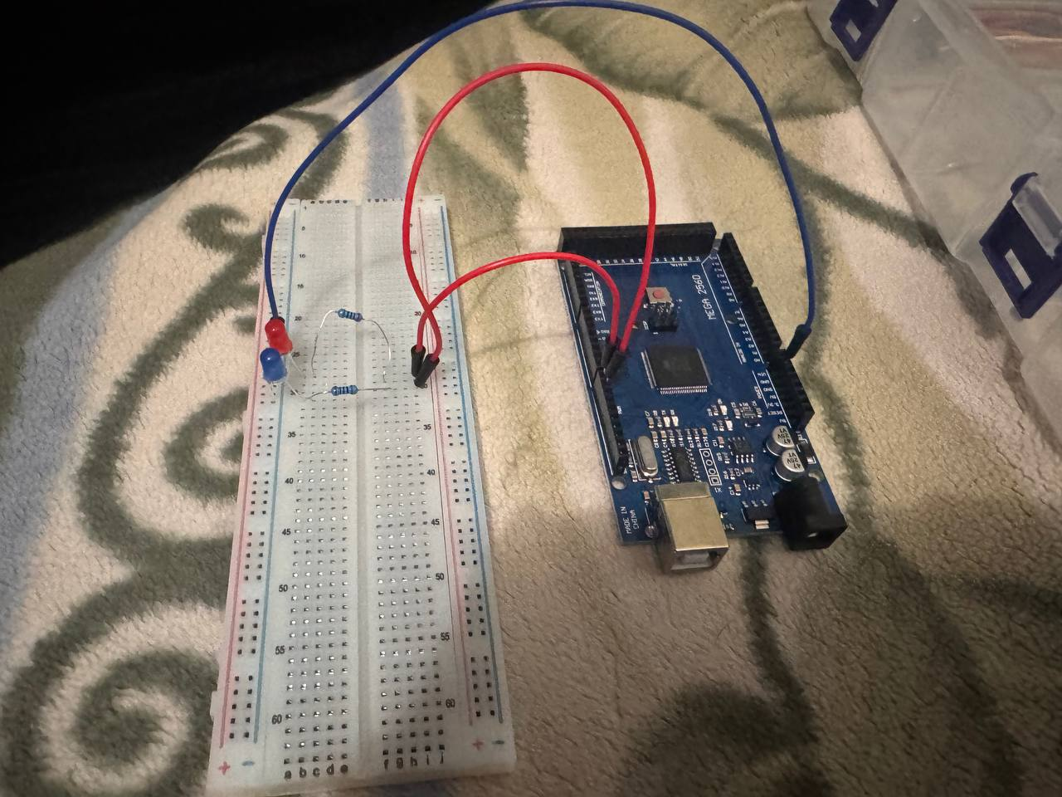

GND Blue Jumper wire(Male to Male) connected to: – on the PowerRails of BreadBoard (PowerRails: 2 parts –and+)
- GND → BreadBoard Power Rail (-)
D9, D8, Red Jumper Wires(Male to Male) connected to:+ on the middle part of the BreadBoard Terminal Strips (Terminal Strips: 2 middle parts of BreadBoard)
- D8 → Red LED (through 220Ω resistor)
- D9 → Blue LED (through 220Ω resistor)
(LEDs, Having 2 legs, 1 is bigger is + (5V, HIGH) and – (0V, LOW)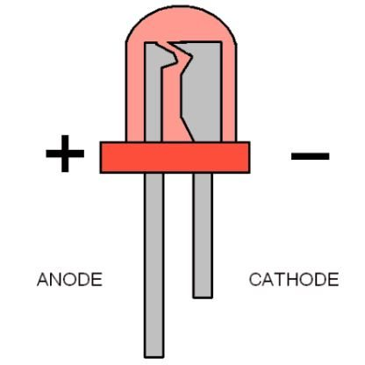
## Components
- Arduino Mega 2560
- BreadBoard
- 2x LEDs
- 2x 220Ω Resistors
- 3x Male-to-Male Jumper Wires

## How It Works
The program simulates a mini police flashing light.
Both LEDs repeatedly turn ON and OFF with a short delay.
The flashing speed can be changed by modifying the delay() value in the code.

## What I Learned
- Using digital output pins.
- Controlling LEDs with digitalWrite().
- Why current-limiting resistors are required.
- Organizing wiring on a BreadBoard.

## Possible Improvements
- Add a buzzer.
- Control flashing speed with a potentiometer.
- Use PWM for smooth fade effects.

## Result
✔ Project works successfully.
✔ Both LEDs flash correctly.

